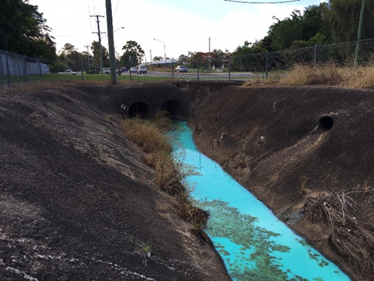
The effects of water pollution
Queensland’s streams, rivers, lakes, wetlands, estuaries, open coastal waters and groundwater are essential to maintaining the health of our environment and our quality of life. Preventing water pollution helps to support healthy natural ecosystems and improves the quality of the water essential for use by people and industry.
Roadside gutters and drains feed stormwater to our creeks, rivers and marine environment. Contaminants such as silt and mud may cause failure of the stormwater system and flooding issues, as well
Image Source: Moreton Bay Regional Council

as harm ecosystems by suffocating aquatic plants, animals and other organisms. Chemical contaminants may also harm ecosystems.

What is a prescribed water contaminant?
In Queensland, the Environmental Protection Regulation 2019 contains a list of prescribed water contaminants. Prescribed water contaminants include pollutants such as chemicals, oil, paint, sediment, animal matter, plant matter, rubbish, regulated waste, sewage and wastewater from outdoor cleaning processes.
A complete list of prescribed water contaminants is included in this fact sheet.

The law
Under the Environmental Protection Act 1994 it is an offence (whether wilfully or unwilfully) to:
- deposit a prescribed water contaminant into stormwater drains, roadside gutters or waterways
- deposit a prescribed water contaminant in a place where it could potentially wash, blow, fall or move into stormwater drains, roadside gutters or waterways
- release stormwater run-off which results in the build-up of earth in stormwater drains, roadside gutters or waterways.
Offences may include an on-the-spot fine to the value of 15 penalty units (individual) or up to 75 penalty units (corporation) or prosecution. Substantial penalties apply if prosecuted, especially in circumstances where the prescribed water contaminants are deposited of wilfully. Refer to the Local Government Toolbox website www.lgtoolbox.qld.gov.au for more information about penalty units.

What you can do
We all need to play our part in ensuring contaminants do not enter the stormwater system. Stormwater is not treated before entering our local creeks, rivers and waterways. You can help protect water resources by:
- having a plan to manage sediment and erosion on building sites and disturbed land to keep contaminants contained
- disposing of all types of waste and wastewater appropriately
- reporting illegal dumping and water pollution incidents to Council or contact the 24/7 Queensland Government pollution hotline for significant pollution incidents on 1300 130 372.
If you require advice on how to dispose of a prescribed water contaminant, contact Council.

List of prescribed water contaminants
Materials which are prescribed as water contaminants under the Environmental Protection Regulation 2019 – Schedule 10:
- A chemical, or chemical waste containing a chemical.
Examples:
- biocide, including herbicide, fungicide and pesticide
- chemical that causes biochemical or chemical oxygen demand
- per and poly-fluoroalkyl substances (PFAS).
- A gas other than oxygen.
- A liquid containing suspended or dissolved solids.
- A liquid that has a temperature different by more than 2°C from ambient water temperature.
- Animal matter, including dead animals, animal remains and animal excreta, and water used to clean animals, animal enclosures or vehicles used for transporting animals.
- Ashes, clay, gravel, sediment, stones and similar organic or inorganic matter.
- A substance that has a pH outside the range 6.5 to 8.5.
- Building and construction materials, including bitumen, brick, cement, concrete and plaster.
Examples:
- cement washed to create exposed aggregate treatment
- coloured powder used to create stencilled concrete features.
- Building, construction and demolition waste, including bitumen, brick, concrete cuttings, plaster and waste water generated by building, construction or demolition.
- Clinical waste.
- Glass, metal parts, paper, piping, plastic and scrap metal.
- Industrial waste.
- Oil, including, for example, petroleum or vegetable based oil.
- Paint, paint scrapings or residues, paint sludge, water used for diluting paint or washing painting utensils, and waste from paint stripping.
- Plant matter, including, for example, bark, lawn clippings, leaves, mulch, pruning waste, sawdust, shavings, woodchip and other waste from forest products.
- Putrescible waste, including, for example, food scraps.
- Regulated waste mentioned in schedule 9, part 1, column 1 as a prescribed water contaminant.
- Sewage and sewage residues, whether treated or untreated, and any other matter containing faecal coliforms or faecal streptococci, including, for example, waste water pumped out from a septic tank.
- Vehicles and components of vehicles, including, for example, batteries and tyres.
- Waste and waste water, generated from indoor cleaning, including, for example, waste from carpet or upholstery cleaning and steam cleaning.
- Waste and waste water, generated from outdoor cleaning, including, for example, waste generated from high pressure water blasting of commercial or industrial premises, fuel dispensing areas, plant or equipment, roofs, streets, vehicles and wharves.
- Waste generated from repairing or servicing motor vehicles, including, for example, engine coolant, grease, lubricants and oil.
- Waste water, including backwash from swimming pools, condensate from compressors, water from air-conditioning or cooling systems and waste water from grease traps.

LG Toolbox recognises the contribution from SEQ Environmental Protection Interest Group to this fact sheet.

